**3-Step Counseling Process**

**Step 3**

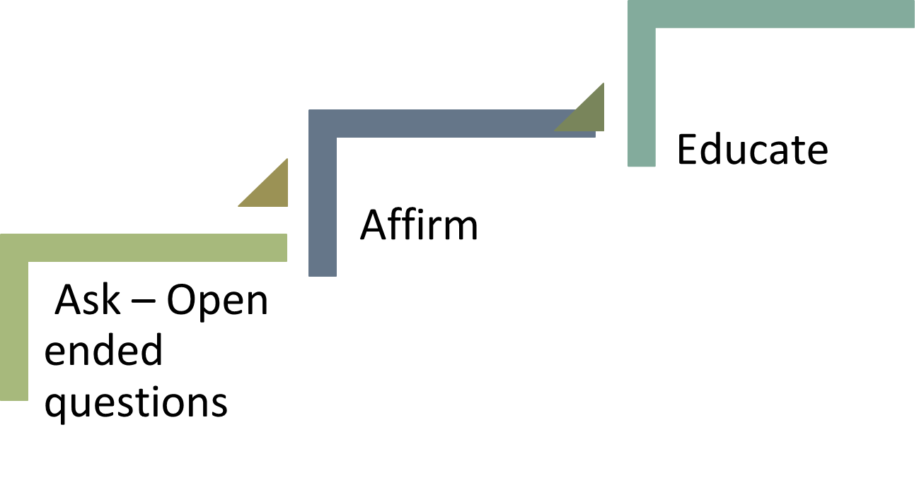

**Step 2**

**Step 1**

**Step 1 – ASK –** Open ended questions help to elicit conversations and more information.

**Step 2** – **AFFIRM –** Validate feelings and praise for what they are doing good, building trust.

**Step 3 – EDUCATE** - After affirming begin to provide information around feelings, concerns, or barriers that were shared.

**REVIEW** – Summarize the conversation to clarify when needed and at the end.

**Set A Goal – SMART** goal can be set by the client around the information provided – start with small goals to help build confidence. Give praise when a goal is met.