**3-Step Counseling Process**

**Step 3**

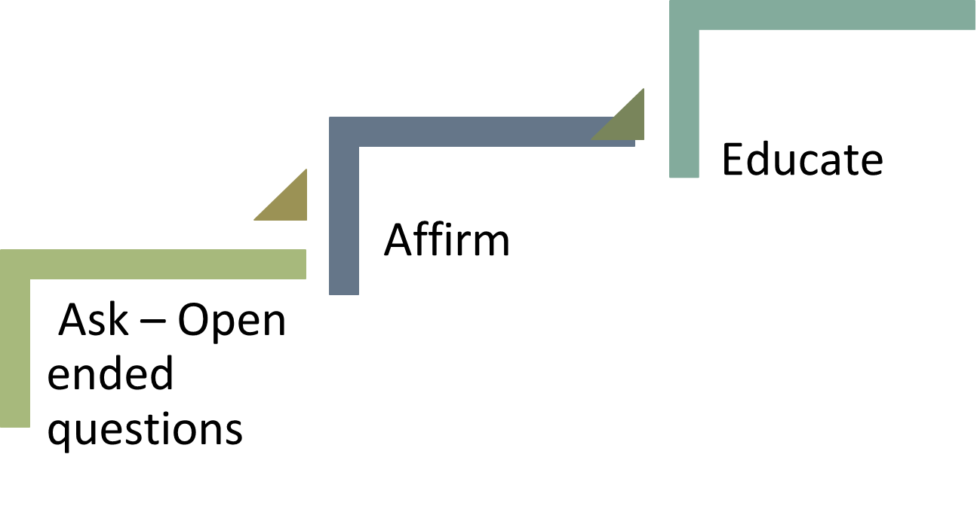

**Step 2**

**Step 1**

**Step 1 – ASK –** Open ended questions help to elicit conversations and more information.

* **Using Probes**
  + **Extending probes to get more information: Tell me more about….**
  + **Clarifying probes to be sure you understand: In other words, you’re saying…**
  + **Reflecting probes to say her words back to her: So, you’re worried about…**
  + **Redirecting probes to change the subject: I’ll give you a referral for that. What other breastfeeding issues would you like to discuss?**

**Step 2** – **AFFIRM –** Validate feelings and praise for what they are doing good, building trust.

* **Show her she’s not alone.**
* **Read between the lines.**
* **Shine the spotlight.**
* **Show her how she is a good mother.**
* **Let her know what she is doing well!**

**Step 3 – EDUCATE** - After affirming begin to provide information around feelings, concerns, or barriers that were shared.

**REVIEW** – Summarize the conversation to clarify when needed and at the end.

**Set A Goal – SMART (Specific, Measurable, Achievable, Realistic, Timely)** goals can be set by the client around the information provided – start with small goals to help build confidence. Give praise when a goal is met.